Exploratory Factor Analysis (2-, 3-, and 4-factor solution)

SPSS Settings for EFA

SPSS settings for initial EFA | SPSS settings for 2-, 3-, and 4-factor solution in EFA
Software: SPSS, version 24  Settings for Descriptives:  Statistics:  check Univariate descriptives  check Initial solution  Correlation matrix:  check Coefficients, Determinant, KMO  Settings for Extraction:  Method: Principal Axis Factoring  Analyze: Correlation matrix  Display: Unrotated factor solution  Display: Scree plot  Extract: Based on Eigenvalues greater than 1  Maximum iterations for convergence: 25  Settings for Rotation:  Method: None  Display: Loading plots  Maximum iterations for convergence: 25  Settings for Options:  Missing values: Exclude cases listwise  Coefficient display format:  Sorted by size  Suppress small coefficients  Absolute value below: .30 | Software: SPSS, version 24  Settings for Descriptives:  Statistics:  check Univariate descriptives  Uncheck Initial solution  Correlation matrix:  check Coefficients, Determinant, KMO  Settings for Extraction:  Method: Principal Axis Factoring  Analyze: Correlation matrix  Display: Unrotated factor solution  Display: Scree plot  Extract: Check Fixed number of factors  Factors to extract: 2 (then 3, then 4)  Maximum iterations for convergence: 25  Settings for Rotation:  Method: Direct Oblimin  Display: Rotated solution  Display: Loading plots  Maximum iterations for convergence: 25  Settings for Options:  Missing values: Exclude cases listwise  Coefficient display format:  Sorted by size  Suppress small coefficients  Absolute value below: .30

Number of subjects/cases  (trigrams) | Number of variables  (languages) | Subject to Variable Ratio  (STV)
521 (sample size) | 11 | STV 47:1 (47 to 1)

The EFAs on the following pages were run using the following Excel data: “trigrams_11_lang_new”
Location of the Excel data: folder “EFA_CFA_HAC_data_Liberato_Aug13”, in sub-folder ”EFA2_and_CFA2”

Descriptive Statistics
 | Mean | Std. Deviation | Analysis N
ARA_normed | 6.05 | 12.58 | 521
CHI_normed | 7.29 | 14.32 | 521
FRE_normed | 8.42 | 16.43 | 521
GER_normed | 9.69 | 16.47 | 521
HIN_normed | 6.36 | 12.39 | 521
ITA_normed | 8.20 | 20.71 | 521
JPN_normed | 9.71 | 19.46 | 521
KOR_normed | 7.26 | 14.31 | 521
SPA_normed | 7.86 | 14.63 | 521
TEL_normed | 6.94 | 14.47 | 521
TUR_normed | 7.31 | 14.32 | 521

Correlation Matrixª
 |  | ARA_normed | CHI_normed | FRE_normed | GER_normed | HIN_normed | ITA_normed
Correlation | ARA_normed | 1.000 | .748 | .709 | .718 | .650 | .672
 | CHI_normed | .748 | 1.000 | .615 | .643 | .634 | .537
 | FRE_normed | .709 | .615 | 1.000 | .795 | .571 | .756
 | GER_normed | .718 | .643 | .795 | 1.000 | .647 | .717
 | HIN_normed | .650 | .634 | .571 | .647 | 1.000 | .501
 | ITA_normed | .672 | .537 | .756 | .717 | .501 | 1.000
 | JPN_normed | .668 | .738 | .603 | .681 | .580 | .628
 | KOR_normed | .707 | .788 | .597 | .640 | .578 | .551
 | SPA_normed | .774 | .614 | .808 | .781 | .598 | .774
 | TEL_normed | .573 | .628 | .391 | .492 | .796 | .377
 | TUR_normed | .727 | .723 | .676 | .701 | .671 | .546

Correlation Matrixª
 |  | JPN_normed | KOR_normed | SPA_normed | TEL_normed | TUR_normed
Correlation | ARA_normed | .668 | .707 | .774 | .573 | .727
 | CHI_normed | .738 | .788 | .614 | .628 | .723
 | FRE_normed | .603 | .597 | .808 | .391 | .676
 | GER_normed | .681 | .640 | .781 | .492 | .701
 | HIN_normed | .580 | .578 | .598 | .796 | .671
 | ITA_normed | .628 | .551 | .774 | .377 | .546
 | JPN_normed | 1.000 | .835 | .643 | .555 | .628
 | KOR_normed | .835 | 1.000 | .602 | .551 | .691
 | SPA_normed | .643 | .602 | 1.000 | .455 | .705
 | TEL_normed | .555 | .551 | .455 | 1.000 | .585
 | TUR_normed | .628 | .691 | .705 | .585 | 1.000

a. Determinant = 2.025E-5

KMO and Bartlett's Test
Kaiser-Meyer-Olkin Measure of Sampling Adequacy. |  | .926
Bartlett's Test of Sphericity | Approx. Chi-Square | 5571.239
 | df | 55
 | Sig. | .000

Communalities
 | Initial | Extraction
ARA_normed | .747 | .750
CHI_normed | .739 | .738
FRE_normed | .760 | .807
GER_normed | .746 | .764
HIN_normed | .736 | .675
ITA_normed | .686 | .702
JPN_normed | .764 | .667
KOR_normed | .780 | .684
SPA_normed | .787 | .822
TEL_normed | .691 | .690
TUR_normed | .696 | .688

Extraction Method: Principal Axis Factoring.

Total Variance Explained
Factor | Initial Eigenvalues |  |  | Extraction Sums of Squared Loadings
 | Total | % of Variance | Cumulative % | Total | % of Variance | Cumulative %
1 | 7.492 | 68.112 | 68.112 | 7.222 | 65.650 | 65.650
2 | 1.038 | 9.432 | 77.544 | .766 | 6.959 | 72.610
3 | .663 | 6.028 | 83.573
4 | .415 | 3.773 | 87.345
5 | .308 | 2.797 | 90.142
6 | .233 | 2.119 | 92.261
7 | .216 | 1.959 | 94.220
8 | .185 | 1.686 | 95.906
9 | .171 | 1.555 | 97.461
10 | .153 | 1.395 | 98.856
11 | .126 | 1.144 | 100.000

Extraction Method: Principal Axis Factoring.

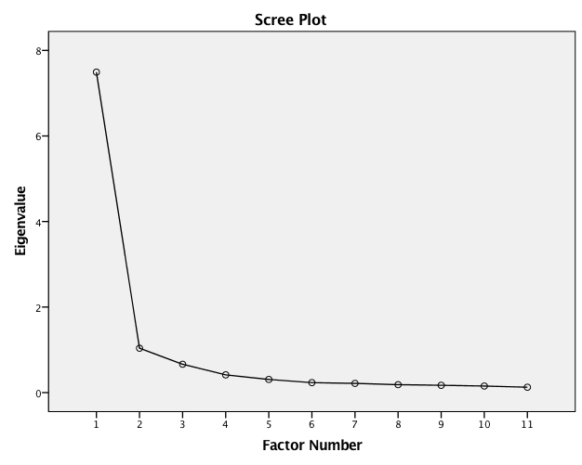

Factor Matrixª  Factor  1 2  ARA_normed .866  SPA_normed .855 -.303  GER_normed .854  CHI_normed .831  FRE_normed .828 -.349  TUR_normed .825  KOR_normed .812  JPN_normed .812  HIN_normed .770  ITA_normed .763 -.346  TEL_normed .679 .479  Extraction Method: Principal Axis Factoring.ª  a. 2 factors extracted. 5 iterations required. | 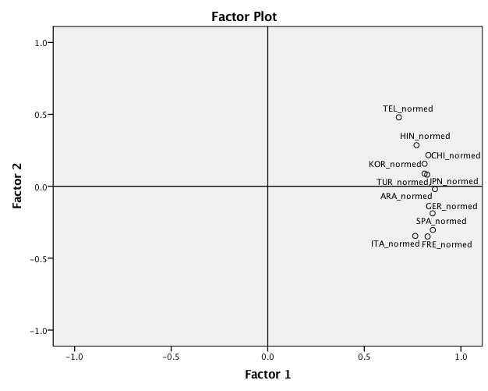

2-factor solution

KMO and Bartlett's Test
Kaiser-Meyer-Olkin Measure of Sampling Adequacy. |  | .926
Bartlett's Test of Sphericity | Approx. Chi-Square | 5571.239
 | df | 55
 | Sig. | .000

Communalities
 | Initial | Extraction
ARA_normed | .747 | .750
CHI_normed | .739 | .738
FRE_normed | .760 | .807
GER_normed | .746 | .764
HIN_normed | .736 | .675
ITA_normed | .686 | .702
JPN_normed | .764 | .667
KOR_normed | .780 | .684
SPA_normed | .787 | .822
TEL_normed | .691 | .690
TUR_normed | .696 | .688

Extraction Method: Principal Axis Factoring.

Total Variance Explained
Factor | Initial Eigenvalues |  |  | Extraction Sums of Squared Loadings |  |  | Rotation Sums of Squared Loadingsª
 | Total | % of Variance | Cumulative % | Total | % of Variance | Cumulative % | Total
1 | 7.492 | 68.112 | 68.112 | 7.222 | 65.650 | 65.650 | 6.352
2 | 1.038 | 9.432 | 77.544 | .766 | 6.959 | 72.610 | 6.017
3 | .663 | 6.028 | 83.573
4 | .415 | 3.773 | 87.345

Extraction Method: Principal Axis Factoring.
a. When factors are correlated, sums of squared loadings cannot be added to obtain a total variance.

Factor Matrixª  Factor  1 2  ARA_normed .866  SPA_normed .855 -.303  GER_normed .854  CHI_normed .831  FRE_normed .828 -.349  TUR_normed .825  KOR_normed .812  JPN_normed .812  HIN_normed .770  ITA_normed .763 -.346  TEL_normed .679 .479  Extraction Method: Principal Axis Factoring.ª  a. 2 factors extracted. 5 iterations required. | Pattern Matrixª  Factor  1 2  FRE_normed .917  SPA_normed .877  ITA_normed .875  GER_normed .735  ARA_normed .534 .409  TEL_normed .948  HIN_normed .748  CHI_normed .691  KOR_normed .605  JPN_normed .371 .518  TUR_normed .387 .516  Extraction Method: Principal Axis Factoring.  Rotation Method: Oblimin with Kaiser Normalization.ª  a. Rotation converged in 16 iterations.
Structure Matrix  Factor  1 2  SPA_normed .906 .640  FRE_normed .898 .596  GER_normed .863 .689  ITA_normed .837 .539  ARA_normed .812 .772  CHI_normed .694 .843  TEL_normed .455 .819  HIN_normed .612 .818  KOR_normed .698 .800  TUR_normed .738 .779  JPN_normed .723 .770  Extraction Method: Principal Axis Factoring.  Rotation Method: Oblimin with Kaiser Normalization. | Factor Correlation Matrix  Factor 1 2  1 1.000 .680  2 .680 1.000  Extraction Method: Principal Axis Factoring.  Rotation Method: Oblimin with Kaiser Normalization.

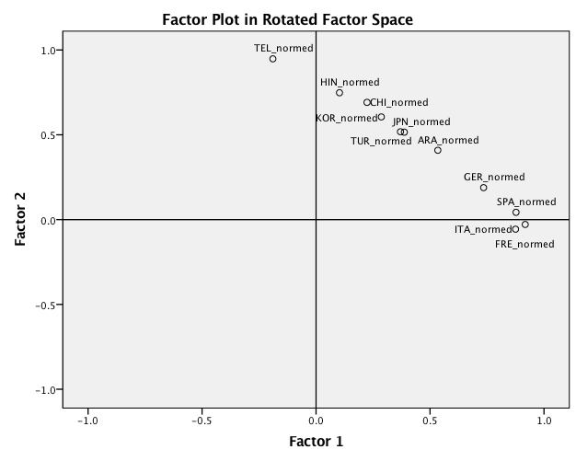

3-factor solution

KMO and Bartlett's Test
Kaiser-Meyer-Olkin Measure of Sampling Adequacy. |  | .926
Bartlett's Test of Sphericity | Approx. Chi-Square | 5571.239
 | df | 55
 | Sig. | .000

Communalities
 | Initial | Extraction
ARA_normed | .747 | .744
CHI_normed | .739 | .759
FRE_normed | .760 | .814
GER_normed | .746 | .769
HIN_normed | .736 | .836
ITA_normed | .686 | .695
JPN_normed | .764 | .752
KOR_normed | .780 | .916
SPA_normed | .787 | .841
TEL_normed | .691 | .796
TUR_normed | .696 | .679

Extraction Method: Principal Axis Factoring.

Total Variance Explained
Factor | Initial Eigenvalues |  |  | Extraction Sums of Squared Loadings |  |  | Rotation Sums of Squared Loadingsª
 | Total | % of Variance | Cumulative % | Total | % of Variance | Cumulative % | Total
1 | 7.492 | 68.112 | 68.112 | 7.274 | 66.131 | 66.131 | 6.329
2 | 1.038 | 9.432 | 77.544 | .830 | 7.541 | 73.672 | 4.818
3 | .663 | 6.028 | 83.573 | .497 | 4.519 | 78.191 | 5.971
4 | .415 | 3.773 | 87.345
5 | .308 | 2.797 | 90.142

Extraction Method: Principal Axis Factoring.
a. When factors are correlated, sums of squared loadings cannot be added to obtain a total variance.

Factor Matrixª  Factor  1 2 3  ARA_normed .862  SPA_normed .853 -.313  GER_normed .851  KOR_normed .836 -.436  CHI_normed .831  FRE_normed .825 -.353  TUR_normed .821  JPN_normed .819  HIN_normed .785 .330 .332  ITA_normed .759 -.341  TEL_normed .687 .520  Extraction Method: Principal Axis Factoring.ª  a. 3 factors extracted. 15 iterations required. | Pattern Matrixª  Factor  1 2 3  FRE_normed .923  SPA_normed .908  ITA_normed .844  GER_normed .738  ARA_normed .500  TUR_normed .376  TEL_normed .882  HIN_normed .826  KOR_normed -1.021  JPN_normed -.734  CHI_normed -.643  Extraction Method: Principal Axis Factoring.  Rotation Method: Oblimin with Kaiser Normalization.ª  a. Rotation converged in 7 iterations.
Structure Matrix  Factor  1 2 3  SPA_normed .917 .554 -.662  FRE_normed .902 .501 -.642  GER_normed .867 .599 -.697  ITA_normed .832 .441 -.604  ARA_normed .811 .663 -.765  TUR_normed .741 .689 -.736  HIN_normed .641 .901 -.626  TEL_normed .470 .888 -.611  KOR_normed .665 .601 -.956  JPN_normed .701 .592 -.860  CHI_normed .680 .694 -.851  Extraction Method: Principal Axis Factoring.  Rotation Method: Oblimin with Kaiser Normalization. | Factor Correlation Matrix  Factor 1 2 3  1 1.000 .578 -.723  2 .578 1.000 -.662  3 -.723 -.662 1.000  Extraction Method: Principal Axis Factoring.  Rotation Method: Oblimin with Kaiser Normalization.

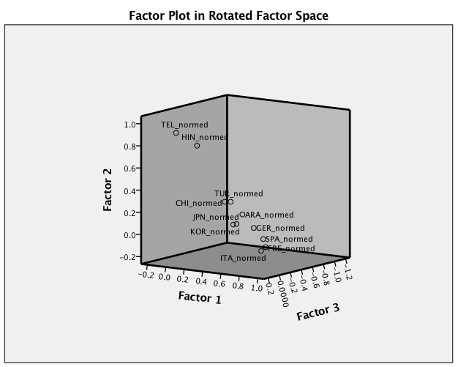

4-factor solution

KMO and Bartlett's Test
Kaiser-Meyer-Olkin Measure of Sampling Adequacy. |  | .926
Bartlett's Test of Sphericity | Approx. Chi-Square | 5571.239
 | df | 55
 | Sig. | .000

Communalities
 | Initial | Extraction
ARA_normed | .747 | .756
CHI_normed | .739 | .783
FRE_normed | .760 | .812
GER_normed | .746 | .766
HIN_normed | .736 | .820
ITA_normed | .686 | .759
JPN_normed | .764 | .876
KOR_normed | .780 | .860
SPA_normed | .787 | .835
TEL_normed | .691 | .837
TUR_normed | .696 | .754

Extraction Method: Principal Axis Factoring.

Total Variance Explained
Factor | Initial Eigenvalues |  |  | Extraction Sums of Squared Loadings |  |  | Rotation Sums of Squared Loadingsª
 | Total | % of Variance | Cumulative % | Total | % of Variance | Cumulative % | Total
1 | 7.492 | 68.112 | 68.112 | 7.296 | 66.332 | 66.332 | 6.261
2 | 1.038 | 9.432 | 77.544 | .850 | 7.726 | 74.058 | 4.817
3 | .663 | 6.028 | 83.573 | .506 | 4.596 | 78.654 | 5.972
4 | .415 | 3.773 | 87.345 | .205 | 1.866 | 80.520 | 1.200
5 | .308 | 2.797 | 90.142
6 | .233 | 2.119 | 92.261

Extraction Method: Principal Axis Factoring.
a. When factors are correlated, sums of squared loadings cannot be added to obtain a total variance.

Factor Matrixª  Factor  1 2 3 4  ARA_normed .862  SPA_normed .851 -.307  GER_normed .849  CHI_normed .833  JPN_normed .832 -.356  KOR_normed .829 -.388  TUR_normed .829  FRE_normed .823 -.349  HIN_normed .782 .322 .315  ITA_normed .765 -.363  TEL_normed .690 .540  Extraction Method: Principal Axis Factoring.ª  a. Attempted to extract 4 factors. More than 25 iterations required. (Convergence=.001). Extraction was terminated. | Pattern Matrixª  Factor  1 2 3 4  FRE_normed .900  SPA_normed .884  ITA_normed .874  GER_normed .719  ARA_normed .486  TUR_normed .355 -.326  TEL_normed .930  HIN_normed .803  KOR_normed -.936  JPN_normed -.859  CHI_normed -.644  Extraction Method: Principal Axis Factoring.  Rotation Method: Oblimin with Kaiser Normalization.ª  a. Rotation converged in 11 iterations.
Structure Matrix  Factor  1 2 3 4  SPA_normed .911 .551 -.662  FRE_normed .897 .496 -.639  GER_normed .862 .598 -.698  ITA_normed .854 .452 -.616  ARA_normed .802 .653 -.756 -.412  TUR_normed .729 .675 -.724 -.547  TEL_normed .460 .910 -.608  HIN_normed .635 .890 -.623 -.330  KOR_normed .656 .605 -.924 -.309  JPN_normed .701 .608 -.914  CHI_normed .664 .684 -.845 -.444  Extraction Method: Principal Axis Factoring.  Rotation Method: Oblimin with Kaiser Normalization. | Factor Correlation Matrix  Factor 1 2 3 4  1 1.000 .567 -.717 -.249  2 .567 1.000 -.661 -.332  3 -.717 -.661 1.000 .264  4 -.249 -.332 .264 1.000  Extraction Method: Principal Axis Factoring.  Rotation Method: Oblimin with Kaiser Normalization.

